

**Faculty of Information, University of Toronto**

**INF1344: Introduction to Statistics for Data Science**

**Professor Abbas Keramati**

Group 11:

Hamid Parsazadeh (997034472)

Isabel Bowman (1003469640)

Kuo-Lun Chang (1007618641)

Bethlehem Zebib (1008516660)

Ragave Vicknarajah (1003959610)

**Communicating Legal Precedent by Estimating Preparation Hours Needed for Criminal Cases**

**Estimating Preparation hours based on Expected Trial Days**

**December 12, 2021**

**TABLE OF CONTENTS**

**x. Summary**

1. **Introduction**

**1.1 Problem Statement and Importance**

**1.2 Background**

**1.2 Research question and objectives**

1. **Methodology**

**2.1 Data Collection**

**2.2 Data Analysis Method**

1. **Statistical population Review**

**3.1 Initial data visualization**

**3.2 Outliers Identification**

**3.3 Population Distribution**

**3.4 Initial Hypotheses**

1. **Model Fitting**
   1. **Initial models comparison**

**4.2 Best model selection**

**4.3 Testing key assumptions**

1. **Conclusion**
   1. **Limitations and Future Analysis**

**Summary**

Managing serious criminal matters such as murder, sexual assault, or weapon offences are difficult, and each case requires a different number of Trial Days to resolve. Lawyers need a certain amount of Preparation Hours to effectively represent the case in court. They are paid by the hour and will rationally ask for the maximum amount of hours possible to maximize their earnings. To mediate this and ensure there is no needless overspending, budget management committees require some rationale to authorize a reasonable amount of Preparation Hours for each case. They often turn to historical cases to grant Preparation Hours based on precedent, looking at the number of hours granted for past cases with a similar number of Trial Hours.

Our team aims to ease the work of budget management teams by devising a statistical method to estimate the number of Preparation Hours that have been historically granted based on the number of Trial Hours for each case. This project will end with a program that could receive a new case ‘Trial Hours’, and output an estimated ‘Preparation Hours’, based on historical data. This would allow for the legal precedent to be communicated clearly and numerically to the committee, thus reducing the bias created by lawyers in charging their clients.

**1. Introduction**

**1.1. Problem Statement and Importance**

When a person is convicted of a serious crime such as murder, sexual assault, or weapon offences their case is most likely taken to court. These cases usually need a lawyer who must prepare for the case by learning every detail. To thoroughly understand the case, a lawyer needs a certain number of hours to prepare in order to effectively present the case in court. A lawyer may prepare for a case by doing the following tasks: understanding the initial investigation of the case, gathering evidence, requesting important documents, preparing exhibits and demonstrative aids for use at the trial, creating detailed outlines of direct testimony and cross-examination questions, creating opening remarks and forceful closing arguments, considering jury selection objectives, and preparing jury instructions (Justice Education Society British Columbia, n.d).

Lawyers are typically paid by the hour; therefore, they tend to ask for the maximum number of hours possible to maximize their personal earnings. However, there is no legally set amount of time for a lawyer to prepare for a trial. The amount of preparation time can range anywhere from none to possibly several years (Trebilcock & Yoon, 2016). This section directly relates to the time length of a trial. To mediate the number of preparation time that lawyers seek and to minimize unnecessary spending, budget management committees require some rationale to authorize a reasonable amount of preparation hours for each case. They often turn to historical cases to grant preparation hours based on precedent, looking at the number of hours granted for past cases with a similar number of Trial Hours. It should be noted that section 11(b) of the Canadian Charter of Rights and Freedoms states that “any person charged with an offence has the right to be tried within a reasonable time” (Government Canada, 2021). The purpose of section 11(b) is to make sure that the trials of those who are charged with a crime are not prolonged or delayed.

Lawyers use a billable hours payment system to input the number of hours they work on a case, which budget management teams keep track of at legal firms. Our team aims to ease the work of such budget management teams by devising a statistical method to estimate the number of preparation hours that have been historically granted based on the number of trial hours for each case. This project would end with a program that could receive a new case’s ‘Trial Hours’, and output an estimated ‘Preparation Hours’, based on historical data. This would allow for the legal precedent to be communicated clearly and numerically to any lawyer representing a case.

A breakdown of the report is as follows: 1) Background of the problem, research question, and hypotheses. 2) Methods – framework, data collection, and modeling techniques utilized. 3) Analytical results. Lastly, 4) Discussion and the limitations of the study.

**1.2. Background**

The purpose of this project was inspired by data from Legal Aid Ontario (LAO). LAO is a publicly funded non-profit organisation, responsible for administering legal aid programs (Legal Aid Ontario, n.d.). In today’s political climate, where many innocent individuals are being charged with crimes they did not commit, it is important to look into how many hours lawyers bill for a case in relation to the number of hours in court. Many lawyers charge hourly rates as the only legal fee option. This is a disadvantage to clients with lawyers who do not adhere to the ethical obligations (Moorhead, 2011). Moorhead (2011) emphasizes the need to address the ethical obligation lawyers have towards their clients and the way a lawyers' self-interest in making a profit collides with such obligations. Using data from a practitioner’s survey, claimant interviews, and existing data from the Department of Business Innovation and Skills, Moorhead’s (2011) findings suggested that lawyers do in fact put their own financial interests before their clients, thus, deliberately overcharging their clients.

Baker (2010) collected data from a survey of individuals who have experienced parental alienation. A particular finding of interest is “only between 16 and 25 percent [of participants] reported that all attorneys were prepared for hearings [...]” (Baker, 2010, p.300). Additionally, Baker (2010) found lawyers that the participants hired for the case became unavailable or difficult to reach after they received the payment for their legal fees, or lawyers would ask for more money than originally agreed upon due to time needed for the case (Baker, 2010). This further confirms the findings from the paper by Moorhead (2011) that many lawyers are focused more on their financial interests over the interests of their clients. For the sake of the client or more specifically the individual that was charged with a crime, it is important their lawyer is charging them appropriately. It is not ethically correct for lawyers to be over charging their clients when the majority of them are not adequately prepared for court even after reassuring their client they are prepared based on the legal fees (Baker, 2010).

**1.3 Research Question and Objectives**

This paper will provide multiple algorithms to achieve an optimal number of preparation hours based on an estimated number of trial days using historical data collected from LAO. The aim of the proposed project is to **find the best algorithm to estimate the number of required Preparation Hours against the estimated number of Trial Days for an upcoming criminal case.**

The following hypotheses were derived from our research question: (1) there is a significant correlation between Trial Days and Authorized Preparation Hours, (2) there is a significant difference between the distributions of different criminal charge categories.

**2. Methodology**

**2.1 Data Collection**

The final dataset was collected from LAO (Legal Aid Ontario) by Hamid Parsazadeh. This particular dataset is focused on specific charges against the defendant (charge), the year (year), the gender of the defendant (gender), the number of days in court (court_d), and the number of hours needed for court preparation (prep_h). All the critical information of the cases are stored in the organization’s database. which ranges from the clients’ demographic and criminal background to the case’s details such as the charges, the acknowledged lawyer and the court’s info. However, based on the initial reviews and communications with the business management team we know that the most relevant information to estimate the required preparation hours for a case, is the estimation of the number of trial days. Therefore, the Est. of Court days was selected as the independent variable in this study.

Moreover, the case management team suggested that historically we can rely on the data from 2010 without any major change in the criminal law with a major influence in our dependent variable (Preparation Hours). Therefore, we selected this dependent variable and requested the data from 2010 to 2020 for all available cases trial days between 1 to 60 days (as the normal trial days). This selection would serve a decent historical dataset for our analysis. The provided data includes the case’s year and the client’s gender as extra descriptive variables and is encrypted (has turned to dummy numbers) to follow the organization’s policies to prevent preaching the client’s privacy and not disclosing the sensitive information.

**2.2 Data Analysis Method**

Prior to creating our algorithms to solve our research question we summarized our data using descriptive statistics. This includes creating multiple scatterplots to plot the preparation hours against the number of days in court for each charge. To test our research questions, we derived multiple algorithms to estimate the number of required Preparation Hours based on the estimated Trial Days for a coming criminal case.

**3. Statistical Population Review**

**3.1 Initial Data Visualization**

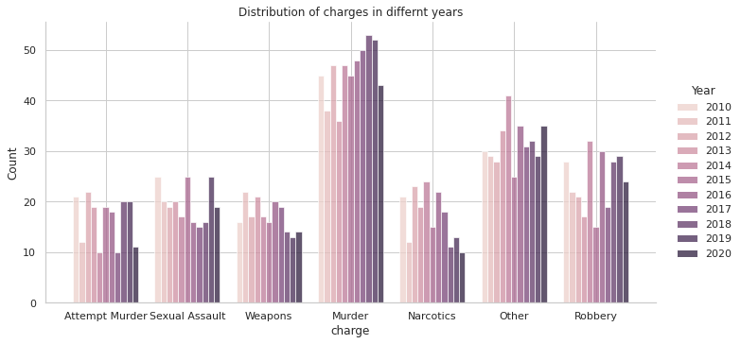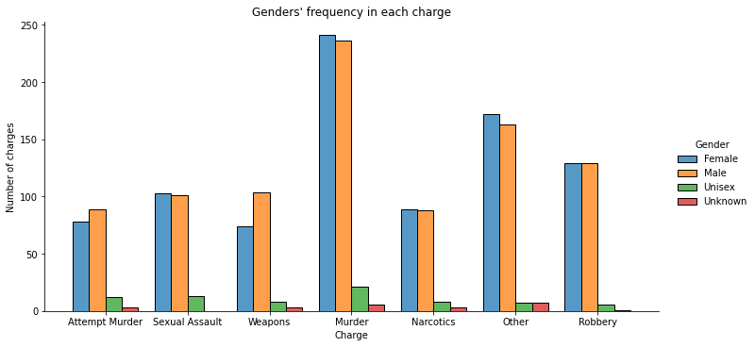

Population is evenly distributed among different genders and different years.

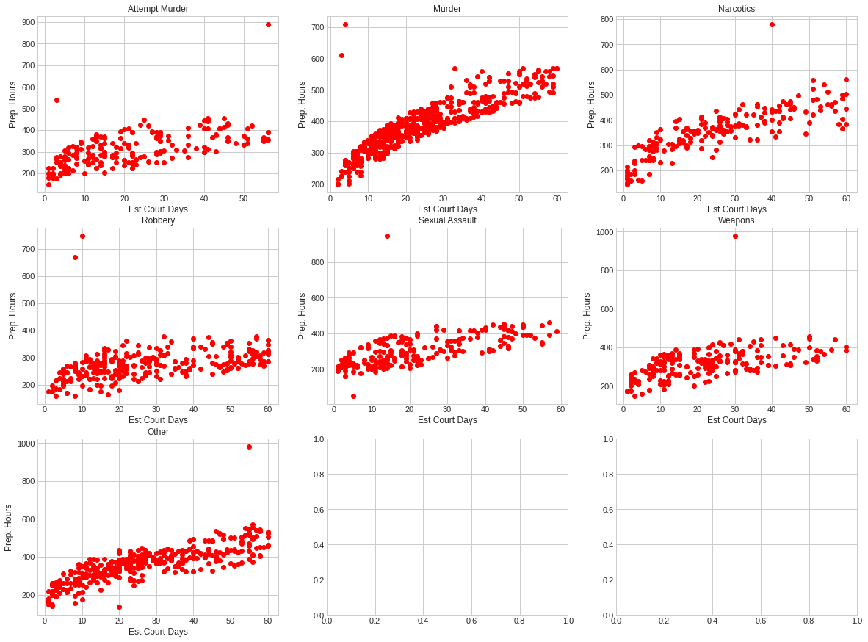

The scatter plots reveal a trend between Estimated Court Days and Total Preparation Hours. Moreover, some potential outliers are observed for different charges.

**3.2 Identifying Outliers**

Outliers were identified by creating a boxplot for each charge, and deeming all values outside 1.5 times of the interquartile range as outliers, according to standard practice.

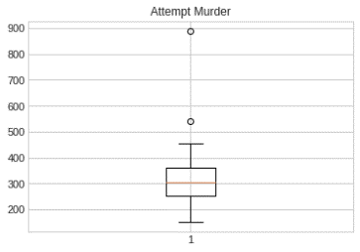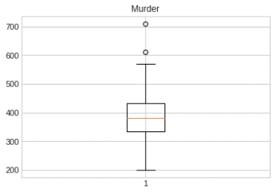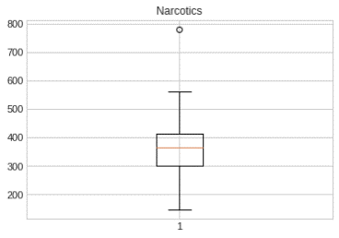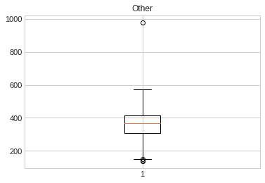

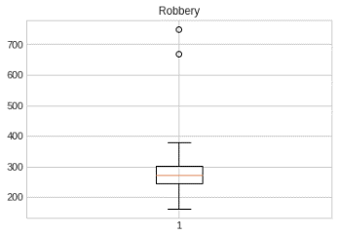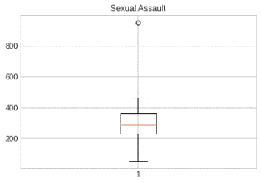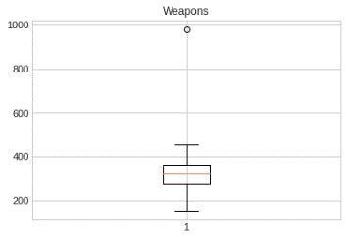

List of outliers:

**Gender Year Court_d Prep_h Charge**



Male 2010 3 540.0 Attempt Murder

Female 2013 56 890.0 Attempt Murder

Male 2020 3 610.0 Murder

Male 2017 4 710.0 Murder

Male 2015 40 750.0 Narcotics

Male 2020 1 148.0 Other

Female 2014 2 140.0 Other

Female 2018 2 150.0 Other

Female 2018 55 980.0 Other

Female 2011 20 135.0 Other

Male 2013 8 670.0 Robbery

Male 2018 10 750.0 Robbery

Female 2016 14 950.0 Sexual Assault

Male 2014 30 980.0 Weapons

We can assume these outliers are due to exceptional cases. Estimating preparation hours for exceptional cases requires the coordination of Case Managers along with the lawyer in charge. These cases will be removed from the dataset to prevent bias in the final model.

**3.3 Populations’ Distribution**

Distribution of each charge:

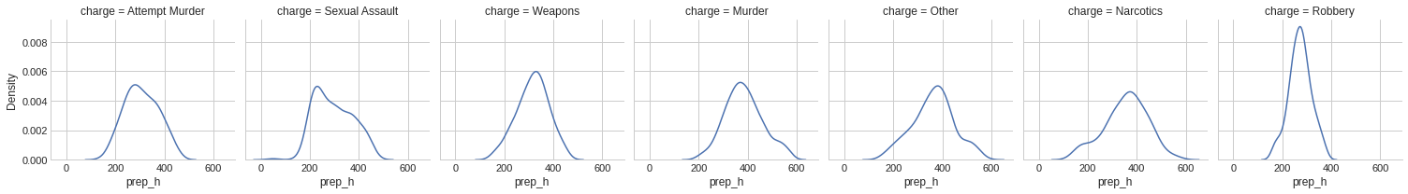

Q-Q plot of each charge:

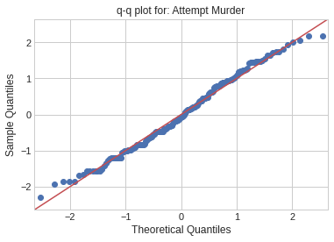 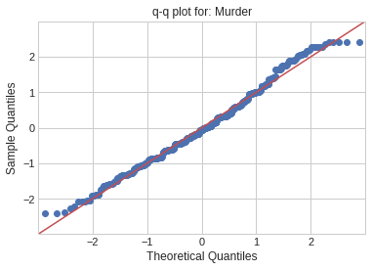 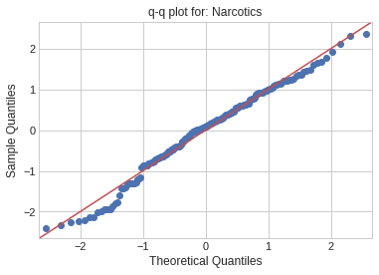 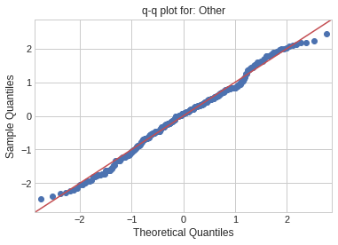

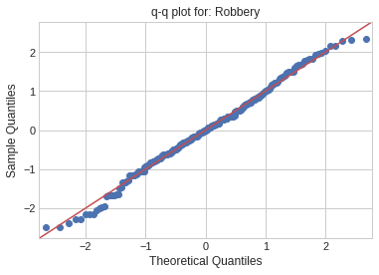 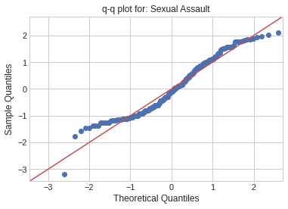 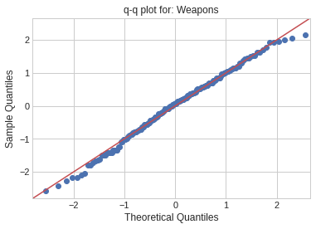

The Q-Q plots show the points of each charge forming a roughly straight line, meaning both the theoretical and sample quantiles come from the same distribution. We can conclude the parameter of each charge has a normal distribution. To verify this finding we use one sample kolmogorov-smirnov test, known as one sample K-S test.

Null and Alternative hypothesis:

$$\{H0: The population distribution is Normal H1: The population distribution is not Normal$$

P_values for each charge:

Attempt Murder: 0.48 Robbery: 0.75

Murder: 0.16 Sexual Assault: 0.02

Narcotics: 0.33 Other: 0.31

Weapons: 0.75

With α = 0.01, we conclude we do not have significant evidence to reject the null hypothesis for all charges. In continuation, we drew a Boxplot for each charge in one graph to have a visual comparison of the population distributions.

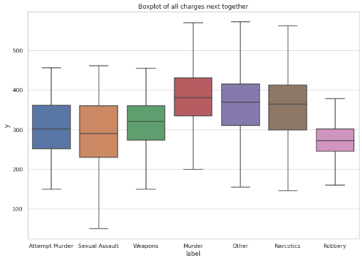

The boxplots indicate that some charges may have similar distributions. Since there is a normal distribution of all the charges, we will need to run a Two Independent Sample Test for comparing the µ and σ of different charges (two by two) to discover similar distributions or verify they are coming from different distributions. Therefore, we will have two sets of hypotheses:

$\{H_{0}: µ_{1}=µ_{2} v.s. H_{1}: µ_{2} ≠ µ_{2}$ and $\{H_{0}: σ_{1}=σ_{2} v.s. H_{1}: σ_{2} ≠ σ_{2}$

Using Python, we ran a Leneve Test and T-Test for comparing variances and means of each set of two charges. [1] The following are p_value matrices of 2x2 comparisons:

*The p_value matrix for*

*The p_value matrix for*

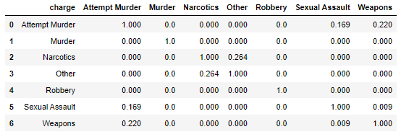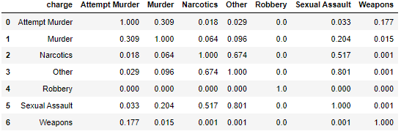

Based on α = 0.01 and the p_value matrices we conclude:

* There is not significant statistical evidence that distributions of “Attempt Murder”, “Sexual Assault” and “Weapons” are different.
* There is not significant statistical evidence that the distribution of “Narcotics” and “Other” are different.

Therefore, we summarize the charges in the following four groups:

* *Group 1: Attempt Murder, Sexual Assault & Weapons*
* *Group 2: Murder*
* *Group 3: Narcotics and Other*
* *Group 4: Robbery*

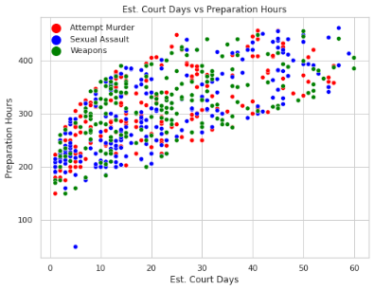 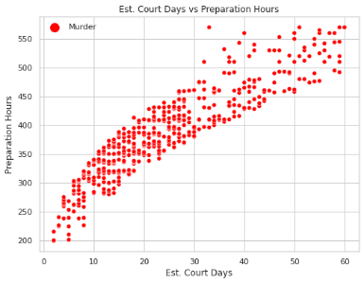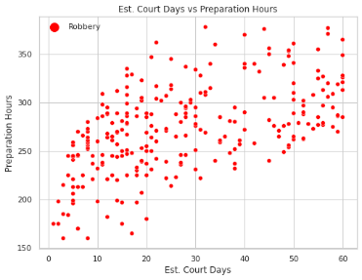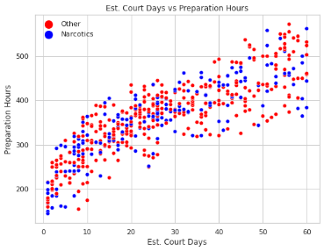

The final step before searching for the best model is ensuring the Estimated Court Days is a statistically proper predictor for the Preparation Hours. We test the correlation between Estimated Court Days and Preparation Hours to verify the significant correlation between these two factors. Therefore, the test hypothesis is as follows:

$$\{H_{0}: ρ_{Est. Court Days, Prep. Hrs} = 0 v.s. H_{1}: ρ_{Est. Court Days, Prep. Hrs} ≠ 0$$

The test distribution is t-student with n-1 degrees of freedom. Using Python function pearsonr() from scipy.stat library we repeat this test for the four groups created above. Here are the correlation and p_value of the tests:

|  |  |  |
| --- | --- | --- |
| **Group** | **Pearson Correlation** | **p_value** |
| *Group 1: Attempt Murder, Sexual Assault & Weapons* | 0.69 | 0.000 |
| *Group 2: Murder* | 0.91 | 0.000 |
| *Group 3: Narcotics and Other* | 0.84 | 0.000 |
| *Group 4: Robbery* | 0.56 | 0.000 |

Since all p_values are 0.0, we reject the null hypothesis and can conclude all groups have statistical evidence that the Pearson correlation between the Estimated Court Days and Preparation Hours is not zero.

As a result, we have four groups of charges coming from four different populations and a statistically reasonable predictor Estimated Court Days. The next section will examine different potential models with a best-fit model using Regression Modeling and Least Square.

**4. Model Fitting**

**4.1. Initial Models Comparison**

Based on the scatter plots in the previous section, the Preparation Hours increases by Estimated Court Days but the slope of the trend reduces gradually for the larger Estimated Court Days, so we observe a curved pattern in all four groups. We will not have a constant in our final model. We fit three different models:

* Model 1: $Y=β_{1} ×lnln \left(X\right) +ε$
* Model 2: $Y=β_{1} ×\sqrt[2]{X} +ε$
* Model 3: $Y=β_{1} ×\sqrt[3]{X} +ε$

By employing a One-Way ANOVA and F-Test we statistically test each model’s fitness, and by One-Sample T-Test, we examine the coefficient(s) individually for each model to ensure it is not zero.[2]

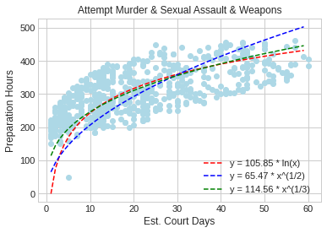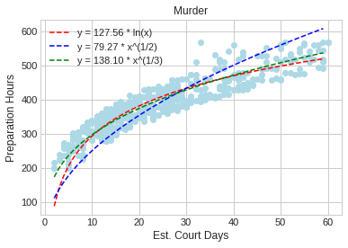

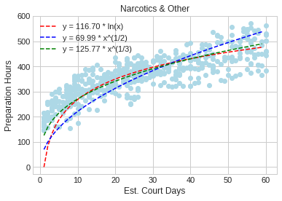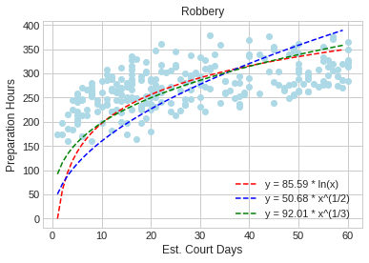

|  |  |  |
| --- | --- | --- |
| **Group (Model 1) $$Y=β_{1} ×lnln \left(X\right) +ε$$** | **One-Way ANOVA (p_value) $${(H}_{0}: β_{1}=0 vs H_{1}: β_{1}≠0)$$** | **Adjusted R-Square** |
| *Group 1: Attempt Murder, Sexual Assault & Weapons* | 0.00 | 0.943 |
| *Group 2: Murder* | 0.00 | 0.992 |
| *Group 3: Narcotics and Other* | 0.00 | 0.973 |
| *Group 4: Robbery* | 0.00 | 0.959 |

|  |  |  |
| --- | --- | --- |
| **Group (Model 2) $$Y=β_{1} ×\sqrt[2]{X} +ε$$** | **One-Way ANOVA (p_value) $${(H}_{0}: β_{1}=0 vs H_{1}: β_{1}≠0)$$** | **Adjusted R-Square** |
| *Group 1: Attempt Murder, Sexual Assault & Weapons* | 0.00 | 0.930 |
| *Group 2: Murder* | 0.00 | 0.982 |
| *Group 3: Narcotics and Other* | 0.00 | 0.965 |
| *Group 4: Robbery* | 0.00 | 0.928 |

|  |  |  |
| --- | --- | --- |
| **Group (Model 3) $$Y=β_{1} ×\sqrt[3]{X} +ε$$** | **One-Way ANOVA (p_value) $${(H}_{0}: β_{1}=0 vs H_{1}: β_{1}≠0)$$** | **Adjusted R-Square** |
| *Group 1: Attempt Murder, Sexual Assault & Weapons* | 0.00 | 0.963 |
| *Group 2: Murder* | 0.00 | 0.994 |
| *Group 3: Narcotics and Other* | 0.00 | 0.984 |
| *Group 4: Robbery* | 0.00 | 0.964 |

**4.2. Best Model Selection**

Since the null hypothesis in the One-Way ANOVA tests is rejected for all three models, we use the Adjusted R-Squares to compare the model and choose the final model with the highest Adjusted R-Square. Therefore, Model 3: $Y=β_{1} ×\sqrt[3]{X} +ε$ is selected as the best fit in all four groups:

|  |  |
| --- | --- |
| **Group (Model 3) $Y=β_{1} ×\sqrt[3]{X} +ε$** | Est. of Coefficient: ${\hat{β}}_{1}$ |
| *Group 1: Attempt Murder, Sexual Assault & Weapons* | 114.5635 |
| *Group 2: Murder* | 138.1031 |
| *Group 3: Narcotics and Other* | 125.7667 |
| *Group 4: Robbery* | 92.0129 |

**4.3. Testing Key Assumptions**

We tested the key assumptions of regression modeling for this model to ensure the selected model is statistically valid. The key assumptions are as follows:

* Residuals must be Normally Distributed (Normal Distribution of Residuals)
  + Test Statistic: One Sample K – S
* Residuals must not be autocorrelated (Serial Correlation)
  + Test Statistic: Durbin-Watson
* Independent variables must not be highly intercorrelated (Multicollinearity or Variance Inflation)
  + Test Statistic: Variance Inflation Factor (VIF)

|  |  |  |  |
| --- | --- | --- | --- |
| **Group (Model 3) $$Y=β_{1} ×\sqrt[3]{X} +ε$$** | **One Sample K-S (p_value)** | **Durbin-Watson** | **Variance Inflation Factor (VIF)** |
| *Group 1: Attempt Murder, Sexual Assault & Weapons* | 0.015 | 1.870 | 1 |
| *Group 2: Murder* | 0.025 | 1.742 | 1 |
| *Group 3: Narcotics and Other* | 0.243 | 1.606 | 1 |
| *Group 4: Robbery* | 0.211 | 1.891 | 1 |

* The p_value of One Sample K-S tests are not less than α = 0.01 so we cannot reject the residuals normal distribution.
* The Durbin-Waston values are within the range of 1.5 to 2.5, so we conclude that the residuals are not autocorrelated.
* We have only one independent variable in this study so we do not need to be worried about the Multicollinearity of the data (significant dependency between independent variables).

**5. Conclusion**

We fit the best models for each criminal charge, by 99% confidence level to predict the number of required preparation hours based on the estimated number of court days. The valid range of Est. Court Days (independent variable) for all charges is 1 to 60 days, since we used this range to fit the models, so models are not statistically valid outside this range. The budget management team can implement the following models for each criminal charge in an upcoming case:

* For Attempt Murder, Sexual Assault & Weapons cases:
$(Prep. Hours)=114.5635 ×\sqrt[3]{(Est. Court Days)}$

* For Murder cases
$(Prep. Hours)=138.1031 ×\sqrt[3]{(Est. Court Days)}$

* For Narcotics & Other cases:
$(Prep. Hours)=125.7667 ×\sqrt[3]{(Est. Court Days)}$

* For Robbery cases:

$(Prep. Hours)=92.0129 ×\sqrt[3]{(Est. Court Days)}$

**5.1 Limitations and Future Analysis**

Lawyers, judges, and juries must not discriminate on the basis of gender, age, and race. Unfortunately, there will be times where ethical practices and judgements are not followed. To complement the results in this report, considering other factors such as race, gender and age could potentially tell a different story. It would also be worth looking into factors regarding lawyers and the ways in which they charge their clients and/or prepare for trials. Because the project focuses heavily on the clients perspective it would be of importance to look into the perspectives of lawyers. Would the correlation between court days and trial prep under different variables such as race, gender or age change considerably?

**References**

* Baker, A. J. (2010). Even when you win you lose: Targeted parents' perceptions of their attorneys. *The American Journal of Family Therapy*, *38*(4), 292–309. https://doi.org/10.1080/01926187.2010.493429
* Government of Canada, D. of J. (2021, September 1). *Section 11(b) – trial within a reasonable time*. Charterpedia. Retrieved December 12, 2021, from https://www.justice.gc.ca/eng/csj-sjc/rfc-dlc/ccrf-ccdl/check/art11b.html.
* *How to prepare your case*. How to Prepare Your Case | Supreme Court BC. (n.d.). Retrieved December 12, 2021, from https://supremecourtbc.ca/civil/prepare-your-case.
* *About lao*. Legal Aid Ontario. (n.d.). Retrieved December 12, 2021, from https://www.legalaid.on.ca/more/corporate/about-lao-landing-page/.
* Moorhead, R. (2011). Filthy lucre: lawyers’ fees and lawyers’ ethics–what is wrong with informed consent? *Legal Studies*, *31*(3), 345-371
* Trebilcock, Michael and Yoon, Albert (2016). "Equality Before the Law? Evaluating Criminal Case Outcomes in Canada." Osgoode Hall Law Journal 53.2 : 587-631. <https://digitalcommons.osgoode.yorku.ca/ohlj/vol53/iss2/7>

1. For T-Tests we use ttest_ind() and for Leneve Test we use leneve() from scipy.stats library.
2. We use curve_fit() from scipy.optimize library and ols() from statmodels.api library